Trevor Kirsch

**CE 650C Homework 1**

*Part 1*

Create a new repository on GitHub (make it public and initiate it with a README.md)

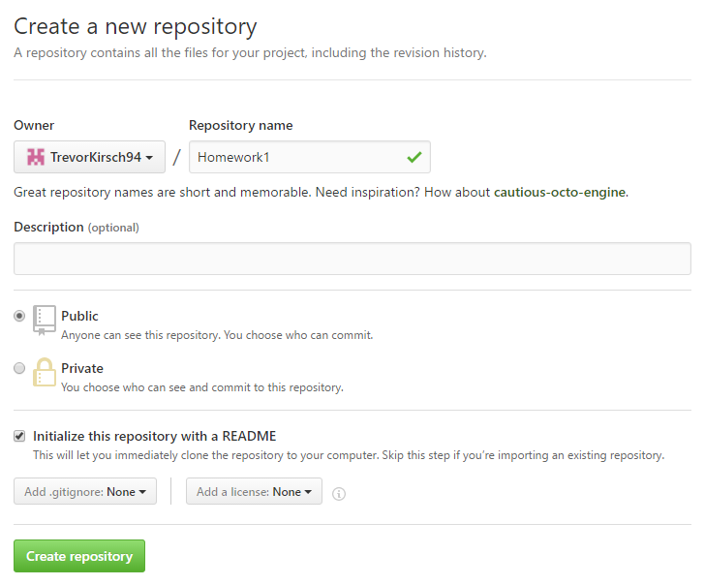

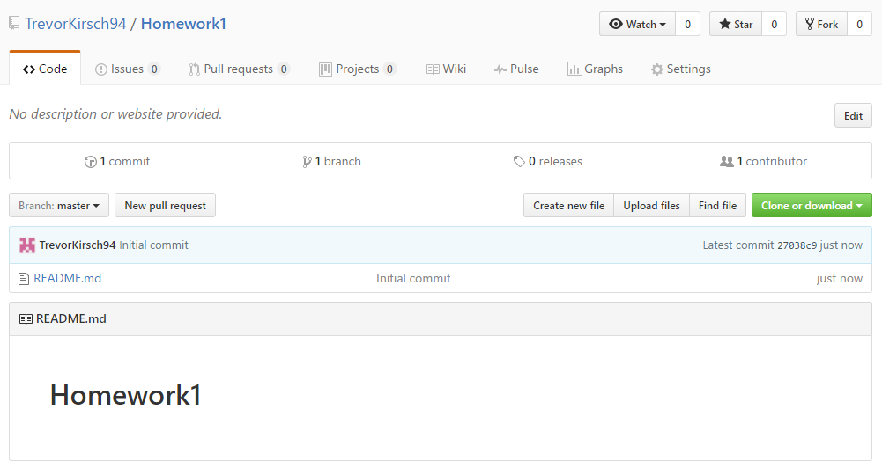

Clone the repository (on the machine that was assigned to you)

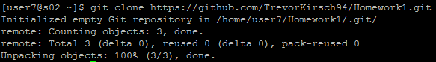

Add a new file to this repository using the “vi editor”



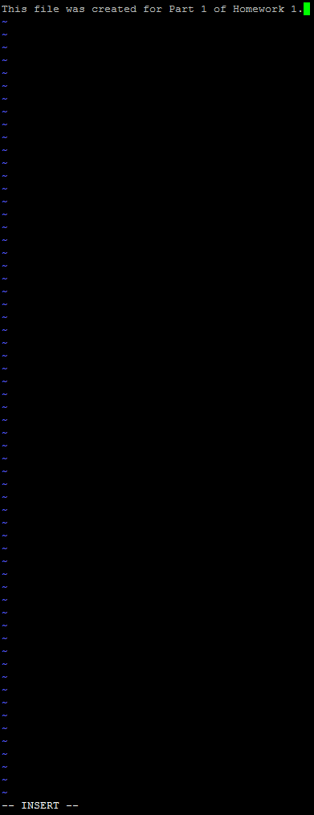

Add the file to tracking



Do a commit



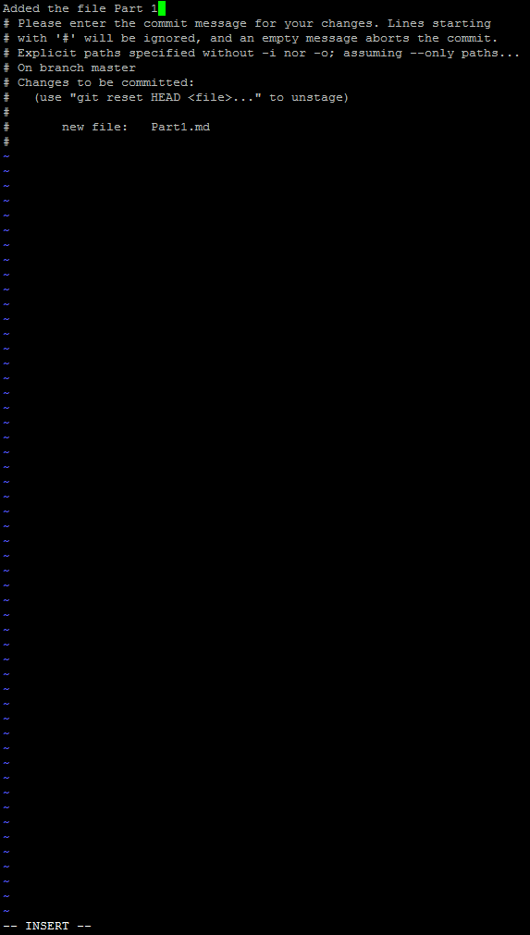

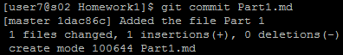

Do a push to your GitHub account



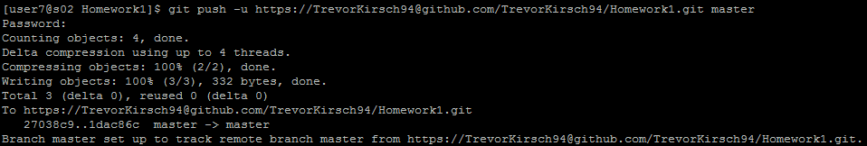

Create a fix (add some lines) to some file in your local repository and do a git merge operation

